Activity: Somebody/Wanted/But/So
Purpose: To construct a graphic organizer to summarize story elements.
- Have students fold a sheet of paper in fourths (or use our graphic organizer) and write the following headings on the four sections: Somebody, Wanted, But, So.
- Using a story that the students have read, have students complete their individual charts by writing a statement under each section:
  - Somebody (identify the character)
  - Wanted (describe the character’s goal)
  - But (describe a conflict that hinders the character)
  - So (describe the resolution of the conflict)
Remind students to focus on information that is most significant.
Lesson variation: Place four Hula-Hoops on the floor, and label each hoop with one of the headings (Somebody, Wanted, But, So). After reading a story, have the students stand inside the hoops and summarize each corresponding aspect as they hop through the hoops.
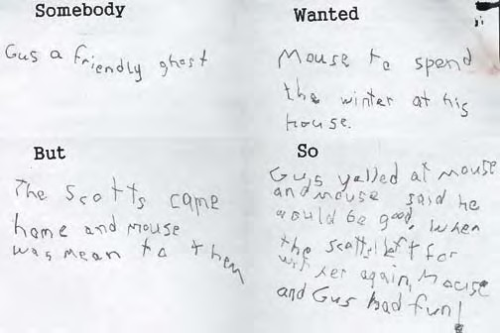
Somebody | Wanted
But | So

